EPROJECT REPORT

Table Of Content

* Acknowledgements
* eProject Synopsis
* eProject Analysis
* eProject Design
  + DFD’s
  + Flow Charts
  + Process Diagrams
  + Database Design / Structure
* Screen Shot’s
* Source Code with Comments
* User Guide
* Developer’s Guide
* Module Descriptions
* ACKNOWLEDGEMENTS

We commence this acknowledgment with heartfelt gratitude to the Lord Almighty, whose divine guidance and blessings have enabled us to successfully shepherd this project from its inception to its triumphant completion.

We extend our sincere appreciation to the dedicated members of our team, each of whom exhibited unwavering commitment and untiring effort throughout the journey. Their collective dedication, teamwork, and tireless work ethic have been instrumental in bringing this project to fruition.

The project was indeed a formidable challenge, one that pushed us to work diligently and provided us with invaluable real-world experience. It has been a profound learning opportunity, enriching our skills and knowledge.

We would like to express our profound gratitude to our esteemed faculty, whose guidance and support were indispensable in shaping the quality and direction of this project. His expertise in the field significantly influenced our work and contributed to its success.

To our friends, families, and the entire Aptech community, we offer our deepest thanks for your unwavering support and constant encouragement throughout this endeavor. Your belief in us has been a constant source of motivation and strength.

We are also immensely grateful for the opportunity to undertake this remarkable project, which has not only benefited us personally but also added value to our skill set and professional development.

In conclusion, we extend our heartfelt thanks to everyone who played a role, no matter how small, in making this project a reality. Your contributions and support have been instrumental in our journey, and for that, we are truly grateful.

Sincerely,

Student1369578 - ADEGORITE RICHARD OMOBOLAJI

Student1369590 - AJIBOLA ABDULHAMEED OLADUNNI

Student1363875 - ODOGWU AMECHI MATTHEW

Student1349198 - SULAIMON HAMZA OMOTAYO

Student1364556 - IRETE VINCENT

Student1346093 - AKINREMI PRINCE OLAIDE ADEWALE

* eProject synopsis

This project was a very insightful one that pushed each of the group members to their limits. In the preliminary stages of the development of this project, each of the group members conducted extensive research on the problem statement, to ensure that we had extensive and quality information on the project demands and to also produce pinpoint results. This necessitated constant collaborative discussion amongst each group member and the faculty to discuss respective discoveries aimed at achieving a concrete understanding of the project. The project entails developing an application for book readers, whereby they have the comfort of reading their favorite books on their phones, without having to download them, or buy books physically.

* eProject Analysis

Problem statement

Ever had a feeling of reading books, but never knew where to start or when to start? Tired of

searching around or paying for books that you would like to read?

Well the books section will let you access the best free websites on phone that will let you read

for free. So improve your reading skills without carrying along weights of books and paying a

single buck.

Can’t find the book you’re willing to read on those sites? No worries the search box will let you

run your dreams books and see if we could find it for you, maybe you’ve to pay to fetch it.

App should have two sections Free Books and Paid Books with proper search options and listing

of books with proper details.

Proposed Solution

After thorough dissecting of the problem statement given, the team got to work on developing the most optimal solution that caters for and solves all the problems the application

* eProject Design

1. DFD’s

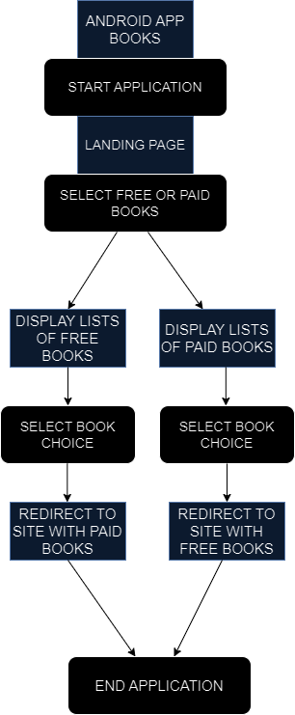

1. Flow Charts

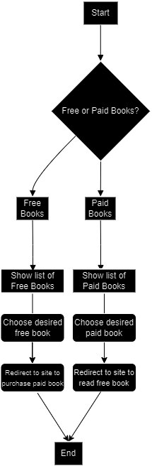

1. Process Diagrams

